Adding Native Trees to your Landscape
Are you looking to add trees to your yard this spring? Native trees are a great way to enhance your landscape while adding benefits to the environment in return. Native trees have grown and adapted with the local environment and wildlife for thousands of years and are important to the local population and ecosystem.

Benefits of Native Trees
- Stormwater: Native trees have developed a deep root system over the years to adapt to floods and droughts that occurred over time. These deep roots absorb water and help to reduce storm water run-off after heavy rains.
- Economic: Native trees provide economic benefit when added to residential yards. Trees can provide shade for a house during hot summer days (reducing cooling costs) and can also provide a blockade for cold winter winds (reducing heating costs).
- Habitat: Native trees are an important part of your local ecosystem. They have co-evolved with native wildlife for thousands of years providing animals with shelter and nutrition.

Choosing a Native Tree for Your Yard
There are a few factors to keep in mind when preparing to select and plant a native tree for your yard:
- How tall and wide will it be at maturity, and what is the shape of the canopy (round or oval)?
- Does the tree produce ornamental fruit?
- Does the spot in my yard have the necessary amount of sun or shade needed for this species?
- What maintenance is required?

Native tree and shrub options categorized by size:
Small/Medium Trees and Shrubs | Description
Muscle Wood | Muscle wood is a small deciduous tree of the Hazelnut family that grows to around 35’ tall in partial sun to shady environments. Learn more here. | 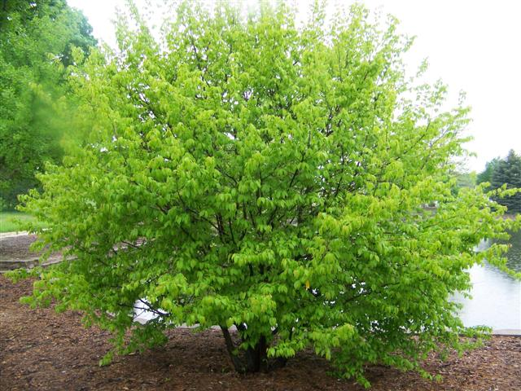
Nannyberry | Description: Nannyberry is a deciduous shrub or small tree of the Honeysuckle family that can grow up to 25’ tall. It has flowers that bloom late spring and develop into colorful fruit. Learn more here. | 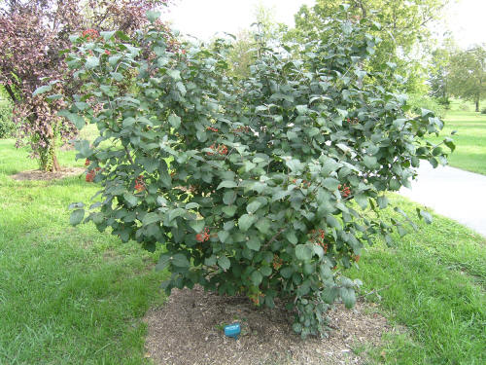
Ninebark | Ninebark is a deciduous shrub of the Rose family that grows up to 3-9’ tall. It is known for its clusters of white flowers that bloom in late spring. Learn more here. | 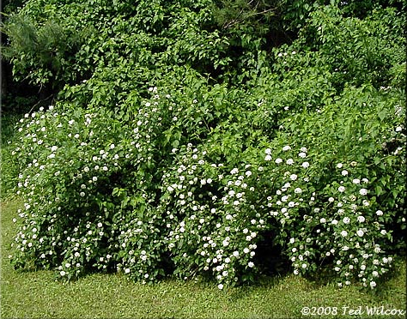
Buttonbush | Buttonbush is a deciduous woody shrub that can sometimes meet the height of a small tree of 20’ tall. They contain sweet fragrant white flowerheads. The nectar and the pollen of the flowers attract many pollinators. Learn more here. | 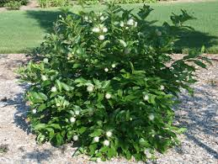

Medium/Large Trees | Description
American Basswood | American Basswood is a deciduous tree of the Basswood family that can grow 50’-100’ tall in full sun to light shade. It contains fragrant cream-colored flowers and develop wide spreading roots. Learn more here. | 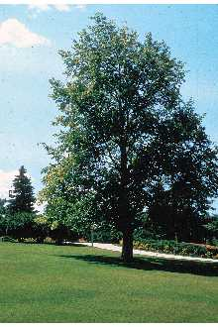
Bur Oak | The Bur Oak tree is a deciduous tree of the Beech family that can grow 80’-120’ tall in moist and deep soil. It has wide spreading branches and produces acorns. Learn more here. | 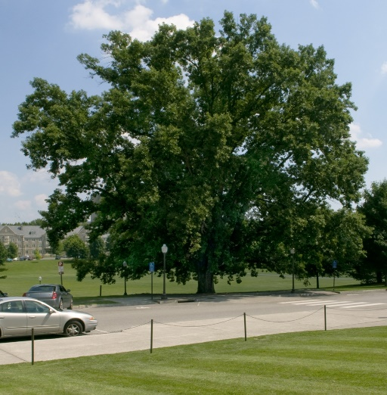

Looking to add one of these trees to your landscape? Here are a few grower and suppliers for native trees:
Natural Communities Native Plants
812 N Washington Ave
Batavia, IL 60510
(331) 248-1016
https://naturalcommunities.net/

Possibility Place Nursery
7548 W. Monee-Manhattan Road
Monee, Illinois 60449
(708) 534-3988
https://www.possibilityplace.com/

The Growing Place (Aurora Location)
2000 Montgomery Road
Aurora, IL 60504
(630) 820-8088

The Growing Place (Naperville Location)
25w471 Plank Road
Naperville, IL 60563
(630) 355-4000
www.thegrowingplace.com

