Garden Refresh: How to Plan a Native Plant Garden
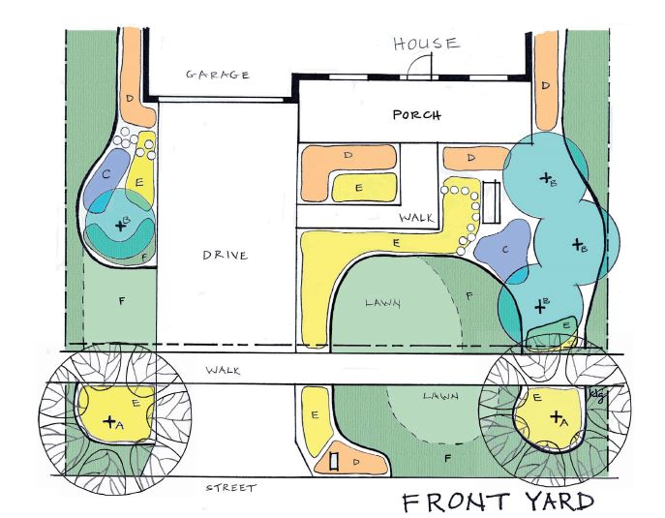
  - An example of a front yard garden plan. Different parts of the yard have different amounts of sun exposure and soil moisture, which should be considered when selecting plants.

Now that spring is here, the plans for the Garden Refresh project are coming along for re-designing and re-planting the native garden beds on two sides of the Clow House at The Conservation Foundation (TCF) McDonald Farm. Since it has been a number of years since the garden beds were planted, it’s time for an update!
The process began on a winter day when staff measured the garden areas and drew it out on paper. Jan Roehll, a landscape architect by training, took the lead on the project. Once she had the area mapped out, noting windows, doors, outlets, gutters, rocks, trees and anything else that needed to be considered, she made working copies for herself and Nancy Cinatl, who has a sustainable landscape certificate and enjoys doing this kind of project. Each of them worked up preliminary ideas for the design and plants to use and then compared notes. Combining the best of their ideas, they quickly agreed on the design plan and plants. For more in-depth details of the project’s planning process, watch the Garden Refresh webinar on TCF’s YouTube channel.
Wondering what it takes to design your own native flower garden? In this blog, we’ll share what you need to consider when selecting and arranging native plants to design beautiful, environmentally friendly landscaping.

Consider Plant Height, Sun Exposure, and Soil Moisture
There is always a number of things to consider when developing a design. The placement of windows and doors are important to keep in mind. Avoid planting trees, bushes, or other tall herbaceous plants in front of doors and windows where they will grow to block the view. Consider putting taller plants toward the back of the bed (between the windows), varying the heights of the plants, and using a tree, bush, or other feature like a birdbath as a focal point. Also, it’s effective to plant in masses and in a way that draws the eye from one grouping to another.
The environmental conditions of your space determine which native plants will thrive in that area. Each side of a building has different sun exposure. Along the front of the Clow House to the left of the front door, the area receives hot afternoon sun. To the right of the front door, there is dappled shade. Therefore, Jan and Nancy selected shade-loving plants for the right of the door, but also included some of the more shade-tolerant varieties from the left side for continuity.
It’s also important to consider the amount of moisture in the soil. For the front of the building, plants were selected for medium-dry conditions. Perennials were chosen rather than annuals because they don’t need constant watering once established. Sun-loving native plants are adapted to life on the prairie and have deeper roots which enables them to tolerate our summer dry spells.

Tips for Expanding Your Garden Bed
A wide garden bed provides more space for different plant heights and groupings. When expanding a flower bed, a garden hose can be used to lay out the edges which then can be spray-painted so the hose isn’t in the way when digging.
If grass needs to be removed, there are easier ways to doing it rather than digging out the lawn. First, mow the grass very short. Then, put down newspaper or cardboard secured with rocks or bricks. The grass will die in a couple of weeks and planting can be done right into the dead grass. Another option is to kill the grass with Roundup. It’s always best to not use poison; however, killing a large area is hard to do any other way.

Keep Your Garden Looking Great
Once the plants are put in, they need some maintenance. Plants need to be watered during the first year and during dry spells in the next couple of years. Once the native plants are established, if they have been appropriately sited, they should not need watering, except for in the driest parts of the summer.
Mulch the beds with leaves, leaf mulch, or finely shredded bark until the plants grow large enough to shade the soil and prevent sun-loving weed seeds from sprouting. The mulch will also help keep the soil from drying out. Weeding will be needed until the plants fill in the spaces. The ultimate goal should be to have the ground covered with plants. At that point weeding should be minimal and manageable. We'll share more maintenance tips throughout the summer and fall.

Sourcing Native Plants
Wondering where you can purchase native plants? There are a number of local native plants sales held in the spring in normal years. TCF is hosting a native plant sale this May. In addition, you can also order plants for delivery to your house through the Possibility Place Native Plant Nursery.
Through TCF’s Conservation@Home program, residents may receive a consultation visit at home to have questions answered and to receive guidance about what plants would work best. Please contact Jan Roehll or Nancy Cinatl at 630-428-4500 with any inquiries about obtaining plants or to arrange a free consultation.
We hope this article will help you plan your own garden. Look for follow-up information once the Garden Refresh planting is completed, currently scheduled for early June.

