Healthy Rivers and Streams Have More Than Just Clean Water
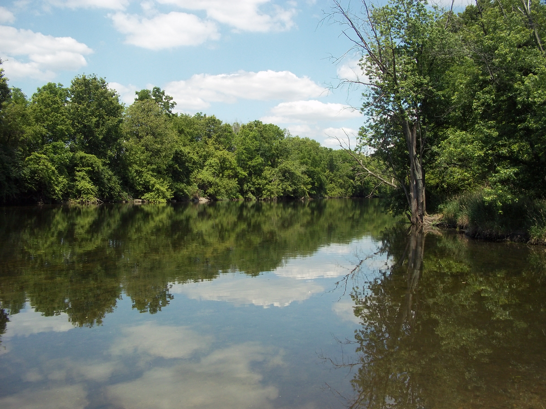
How healthy is your local stream, lake or pond? Finding the answer requires looking at the three major components of water quality: chemical, physical and biological.
Chemical is the one that most people think of when you talk about water quality--how much of a particular pollutant is in the water? But the biology, the critters that live there like fish, insects and mussels, and the physical habitat, like riffles and pools in streams or differing depths in a pond, are just as important. We will look at these three components to understand how they work together.
Water Chemistry: What’s in the Water?
One of the most important components of water chemistry is not a pollutant at all – it is dissolved oxygen. Just like people, things that live in the water need oxygen to “breath” through gills or other structures.
Pollutants are important to consider as well. When it rains, pollutants like fertilizer, road salt, animal waste, soil and fluids that leak from vehicles wash off our landscape and drain into local water bodies. These pollutants harm aquatic life in different ways. Pollutants can decrease oxygen in the water, stress aquatic life and limit reproduction, cover important egg-laying habitat or create toxic conditions.
Local wastewater treatment plants work hard to clean wastewater and be good stewards of the streams they discharge to. You can also do your part by keeping pollutants out of storm sewers that drain directly to local water bodies.
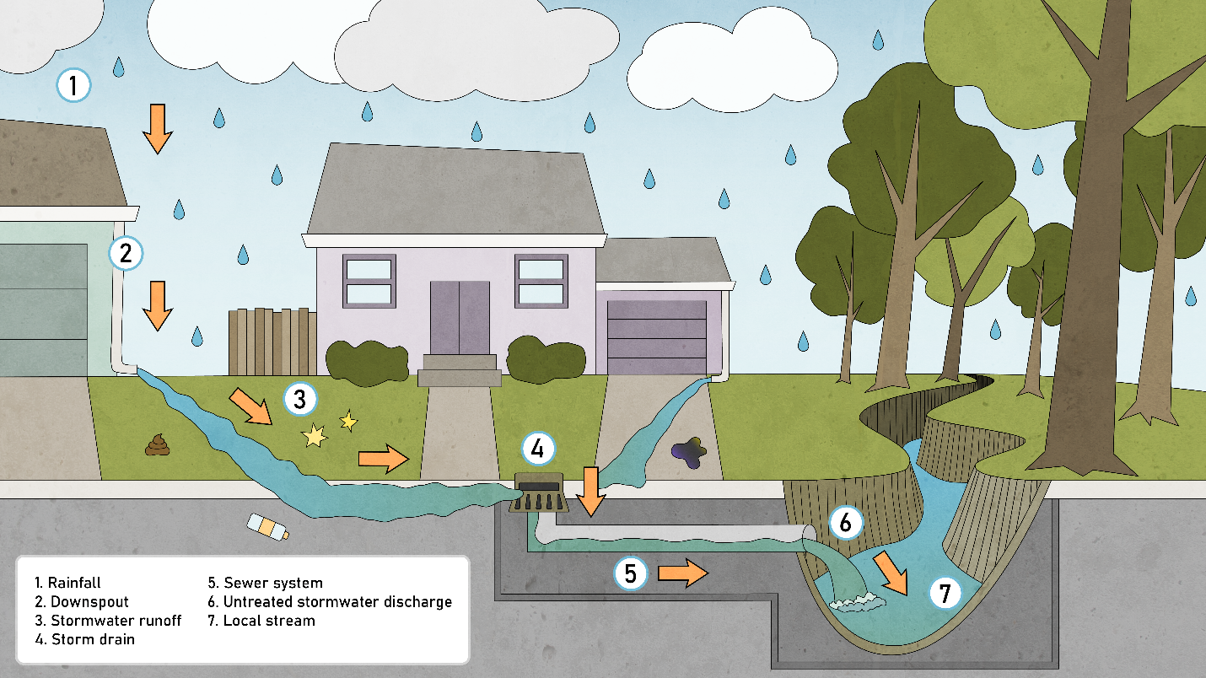
What we do on the land impacts the health of nearby rivers and streams. Stormwater runoff moves pollutants off the land and into waterways. Consider what you put on your lawn and driveway as well as where stormwater goes on your property. Does it soak into the soil or flow over it?
Physical Habitat: Are There Homes for Fish and Bugs? Is the Shoreline Secure?
Physical habitat has many components and includes not only the structure under the water, but also the riparian area – the land along a stream or around a lake or pond. Streams should have curves, areas with slow water and areas with faster water, deep pools for overwintering fish and insects, and dry areas for part of the summer. The bottom of the stream should have gravel and rocks of differing sizes. The more diverse the physical habitat is, the more diverse the aquatic life that live there. Ideally, the stream should also be free of obstructions like dams that impede fish from moving through the stream system.
In detention ponds or lakes, it is important to have a shallow area for plants to grow to help protect the shoreline from erosion. Encouraging native plants along streams and detention ponds not only helps reduce erosion, it also provides important structure and food sources for the adult stages of aquatic insects.
This is an area where bigger is better-- the wider the riparian area or buffer the more benefit to the health of the water body. These buffers also provide a safe place for water to go during big rain events when the streams overflow the banks. Deep-rooted native plants help infiltrate rainwater into the soil and filter out pollutants.
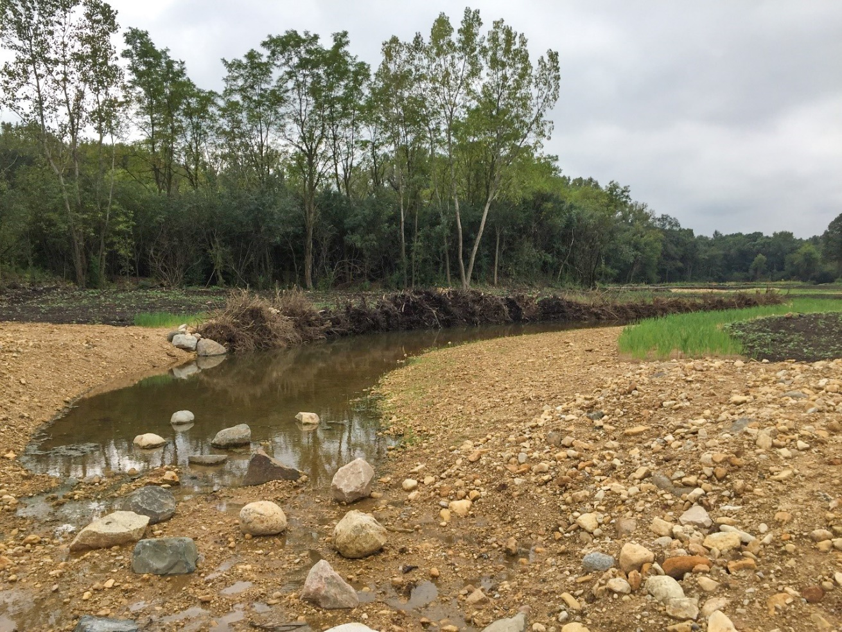
This stream restoration project aims to diversify in-stream habitat. Boulders and cobbles in the stream will create riffles. Tree root wads stabilize the shoreline and provide protection to young fish.

Biology: What Lives in the Water?
The last component of water quality is biological – this is the ultimate measure. We can have “clean” water but no habitat (think of a bathtub). Or we can have really nice, diverse habitat but toxic water. Either situation would result in few or no aquatic species.
So, the fish and insects we find in the water tell us how “clean” the water is and how good the habitat is. Certain fish and insects are very intolerant to pollution, while others can handle some or a lot of pollution. Some species don’t mind muddy bottoms and cloudy water, while others need riffles and gravely bottoms. There are also different groups of fish: fish that eat plants, fish that eat insects and fish that eat other fish (and insects). The same is true for insects – some eat plants and debris and some eat other insects or even small fish and tadpoles. It is important to have representatives from each group to have a healthy aquatic community.
Although we usually think of the amount chemical pollutants in the water when we talk about water quality, we also need to look at the physical habitat and who is living there to get the whole picture.

[Short Version or Summary, 115 words]
How healthy is your local stream, lake or pond? Finding the answer requires looking at the three major components of water quality: chemical, physical and biological. A healthy stream has clean water (the chemistry), plenty of habitat for the life in and around the stream (the physical structure) and diverse aquatic species (the biology). The stream’s biology is the ultimate measure of health. We can have “clean” water but no habitat (think of a bathtub). Or we can have really nice, diverse habitat but toxic water. Either situation would result in few or no aquatic species. For healthy rivers and streams, we must consider all three components when creating projects to restore our local waterways.

