Introducing Garden Refresh: Update Your Landscaping with Native Plants

In the midst of winter, many of you look forward to getting seed and bulb catalogs, eagerly thumbing through them, dreaming of springtime and warmer weather. The Conservation Foundation looks forward to re-doing the garden beds on the east and south sides of the Clow House office space at McDonald Farm in Naperville. In those beds, staff will plant native flowers and grasses to create a garden that is both environmentally friendly and attractive.

It’s been quite a few years since these beds were planted. Some plants prospered and grew too big for the space while others died out and left bare spots and openings for weed seeds to sprout. This spring, staff will remove and replant the remaining vegetation and add in new plants. The revitalized garden beds will serve as a model for homeowners, hopefully inspiring visitors to incorporate native plants into their own gardens.

To create attractive and healthy garden beds, you need to intentionally select and arrange plants. The first step is to measure the garden beds and draw the beds on paper using a scale of 1/4 inch = 1 foot. Next, staff will consider the height and shape of the plants, keeping in mind their full-grown form. Typically, taller and bushier plants will best fit closer to the foundation while smaller and shorter plants will fill in the rest of the garden. Based on the amount of sunlight and soil moisture in the area, staff will choose native plants best adapted to those conditions. Plants are like all other living things—they need optimal conditions to thrive. Finally, staff will plant the garden in May when both air and soil temperatures are warmer.

The Conservation Foundation encourages native plants since they are well-adapted to our climate. Therefore, they can survive our winter freezes and summer dry spells. Also, native plants are important to wildlife, particularly insects and birds, and are useful in soaking up rain water, which reduces stormwater runoff.

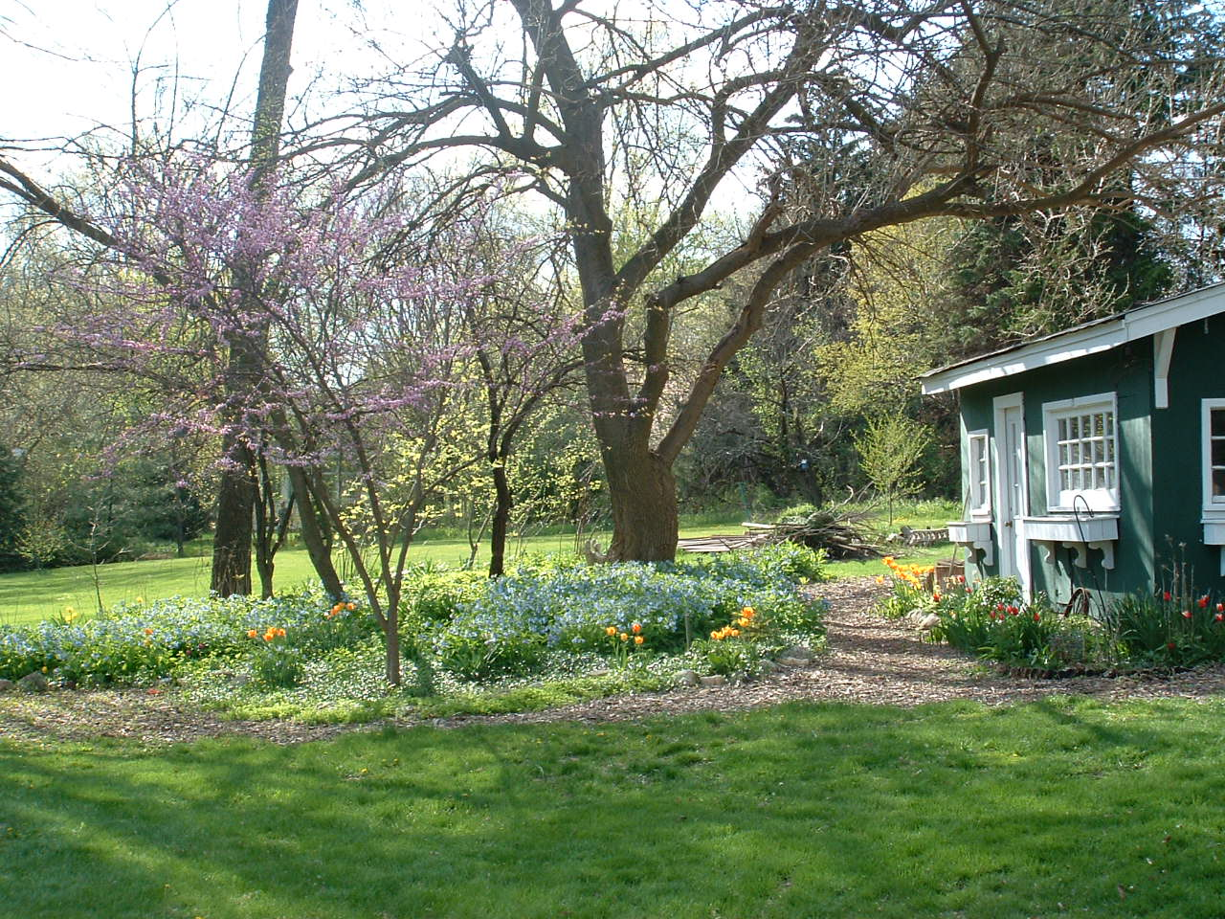
  - A native garden doesn’t have to be all or nothing. This yard incorporates native Virginia bluebells and eastern redbud into their landscaping while keeping a few non-natives like tulips.

The Conservation Foundation hosted a webinar with more details about the project. The presentation covers the attributes of the native plants that were chosen as well as where they can be purchased. This is an opportunity to learn how to spruce up an overgrown or barren garden space and help the environment at the same time.

Throughout the process of revamping the native garden beds, The Conservation Foundation will document the journey through blog posts, pictures, and videos. We hope you’ll enjoy following along with this project throughout the summer and into the fall!

