How Winter Salt Affects Our Pets – And What You Can Do About It

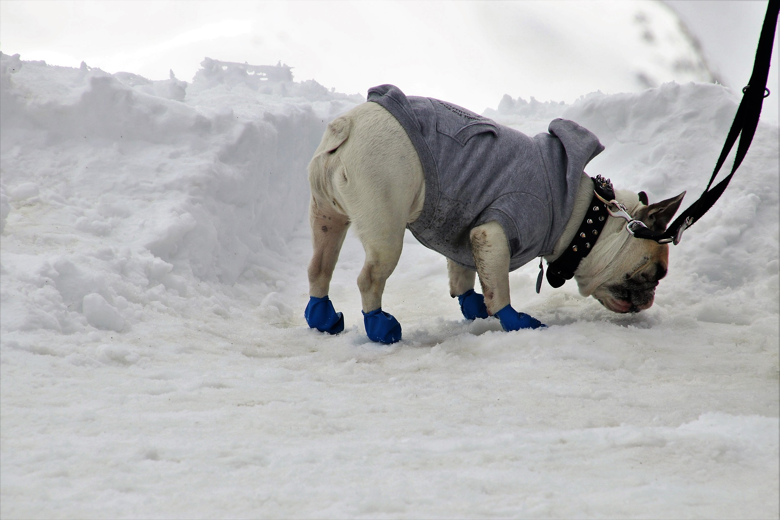

The salt on sidewalks, parking lots, and roads can help keep us safe from icy patches in the winter time, but salt isn’t good for our pets.
A majority of the time, a pet ingests salt or ice melt by accident. The small granules can get stuck between their toes or fur on their feet. Dogs, especially, may lick their feet to get the salt grains out from between their toes. Additionally, some dogs enjoy the taste of salt and may eat it off the pavement or out of the packaging in much larger quantities.
Causal contact, from walking outside, for example, usually doesn’t cause major problems for pets. Most of the time, salt causes mild irritation to your pet’s feet and dry or cracked paw pads. If they eat a salt or ice melt product, it can cause vomiting, increased salivation, or a poor appetite. If your pet does ingest ice melt or salt, it’s a good idea to call your vet for advice. Too much salt, and potentially other ingredients in these products, can cause problems for your pet’s health.

What can we do about it?
To help protect our pets, there are a few easy things we can do:
- Before using any ice melt products, shovel, brush, snow blow, or scrape up any snow or ice to prevent icy spots from forming. Then, only use the amount of salt or ice melt necessary to keep sidewalks and parking lots safe. Sweep up any extra that may be left behind after the ice melts away.
- Try using a product, like a paw wax that you rub on your dog’s feet, before taking them outside during the wintertime. Paw wax creates a waxy layer between the salt and your dog’s feet that helps reduce the irritation from salt.
- Use booties for your pet’s feet. Booties keep the salt off your dog's feet and help keep them warm during cold temperatures.
- Watch your pet when they are outside and discourage them from eating any ice melt, snow, or slush on the ground, particularly along driveways, sidewalks and parkways.
- Always wipe down your pet’s feet when they come back inside. Use a towel to get between the toes and rinse their feet in warm water to help dissolve and dilute any leftover salt.
- Store ice melt products away from your pets so they can’t access it.
- Encourage your friends and neighbors to first remove snow and ice with brooms, shovels, and scrapers and then use salt only on the remaining icy patches.

Pet Safe Products
Instead of using a salt-based product, try using an ice melt product that has urea in it, but don’t use more than you need to melt the ice. Often products marketed as “pet safe” usually have urea or propylene glycol. These products melt the ice like salt, but can cause less toxicity issues in pets. If you need to use a salt product for melting ice, look for one with magnesium chloride. Of the salts used to melt snow and ice, magnesium chloride is the safest for pets. Don’t use any product that has antifreeze or ethylene glycol in it—these chemicals are extremely toxic to pets.
Unfortunately, there aren’t labeling laws for ice melt products, so it is still a good idea to use the smallest amount of a product that you need and practice the protective tips listed above, like wiping your dog’s paws when they come back inside.

Key Takeaways
- Help keep your pets safe this winter by using less salt. Shovel, brush, scrape, or snow blow to clear as much snow and ice first, then only use salt where it is needed.
- Rinse your pet’s feet in warm water when they come inside or use booties to keep the salt off their feet.
- Store salt products away from pets.
- Watch your pet when they are outside so they don’t eat the salt off the sidewalk.

Sources: Wisconsin Salt Wise Presentation, https://www.youtube.com/watch?v=Ql8s_i5BniY and ASPCA, https://www.aspca.org/news/keeping-pets-safe-during-winter-dangers-ice-melts

