Reduce Flooding and Protect Rivers with Rain Barrels

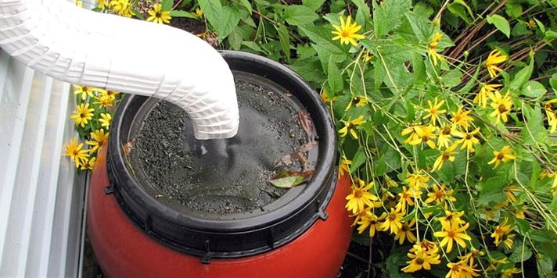

Rainwater is a Precious Fresh Water Resource!
When we think of our stormwater as a precious fresh water resource, it doesn’t make sense to manage it like a waste product. There is a finite amount of fresh water on earth and we can all take steps to protect it, starting with collecting it where it falls!
When we catch and collect the rainwater that falls on our houses, we reduce local flooding and stress on storm sewer system infrastructure while keeping pollutants out of our rivers and streams. We also end up with a bunch of clean water that is perfect for watering lawns and gardens, washing cars or the family dog, and offsetting household water usage in many other ways.
Estimates indicate that a quarter-inch of rain falling on an average home yields over 200 gallons of water. One simple, efficient, low-cost method to reduce the amount of stormwater runoff from your property is to use rain barrels.

What is a Rain Barrel?

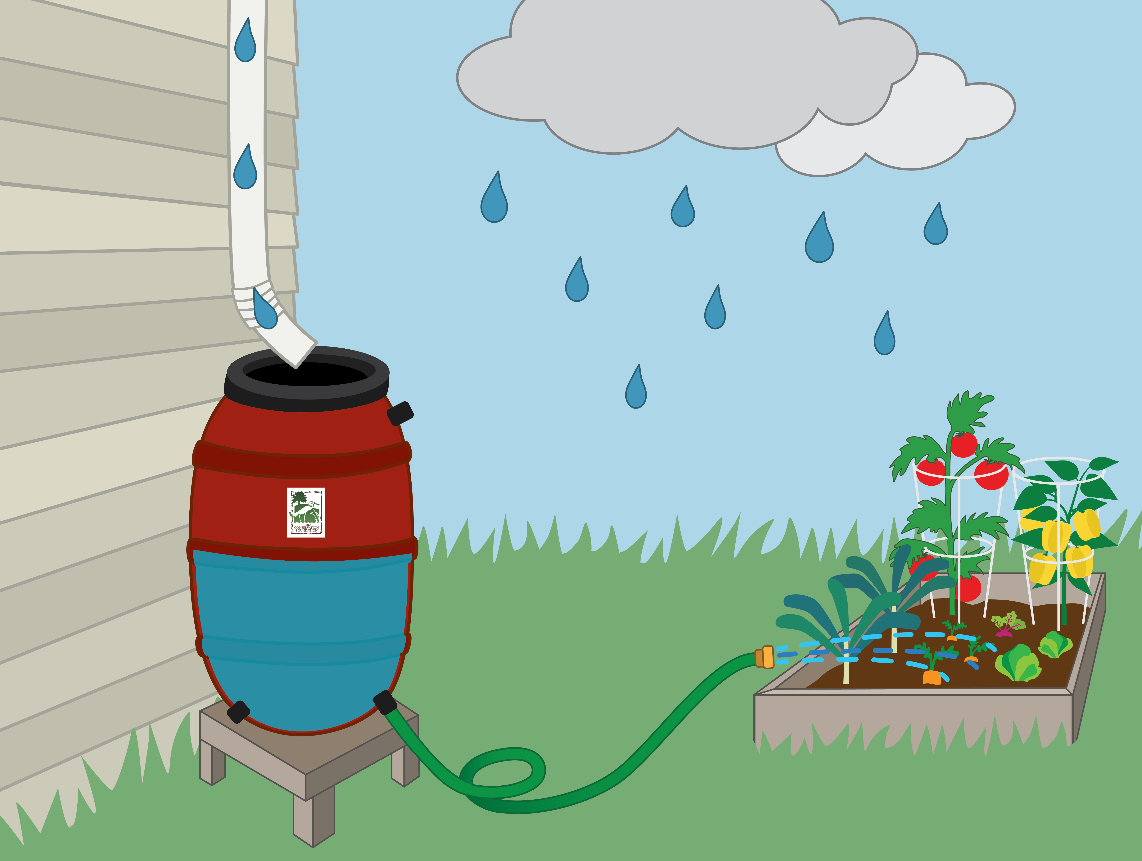
Rain barrels are simply large containers that capture stormwater from your roof that would otherwise be lost as runoff. Modern rain barrels are sealed, safe around children and insect resistant – they can even be painted or decorated to your liking. You can divert water from your downspout to fill your rain barrel and a hose spigot on the front makes the water easy to access and use.
Around 40% of total household water used during the summer months is for watering lawns and gardens. Rainwater doesn’t contain chlorine, lime or calcium which makes it ideal for watering your flowers and vegetable garden or washing your car or windows. You may even notice a decrease in your water bill!
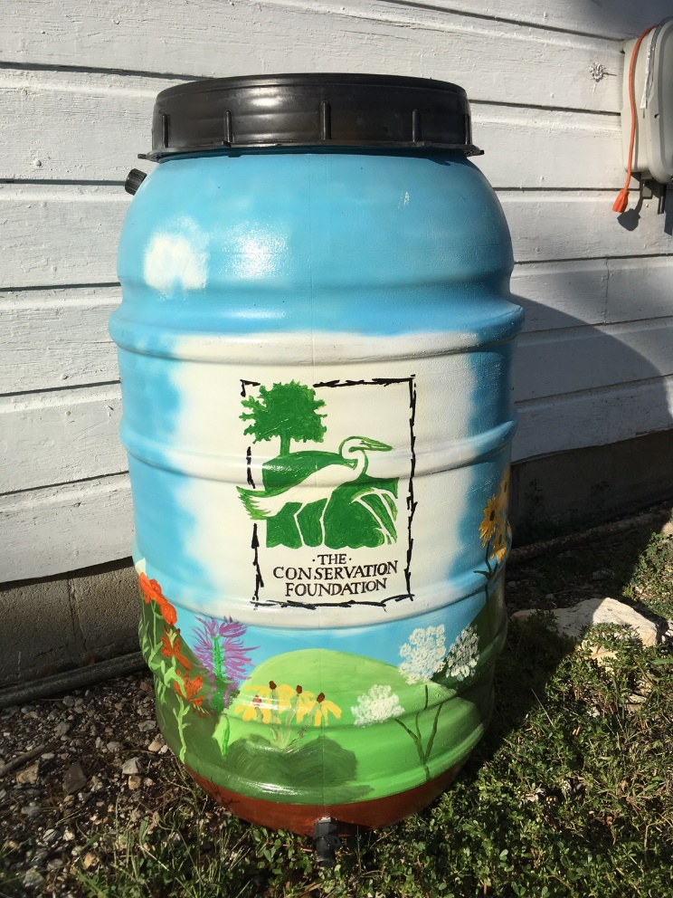
Even if you don’t have an intended use for the water, emptying the rain barrel after a storm reduces the rate and volume of stormwater the storm sewer system and our rivers have to manage at a peak time.

How Can I Get a Rain Barrel?[Insert community rain barrel program details here or leave information about TCF rain barrel program below]

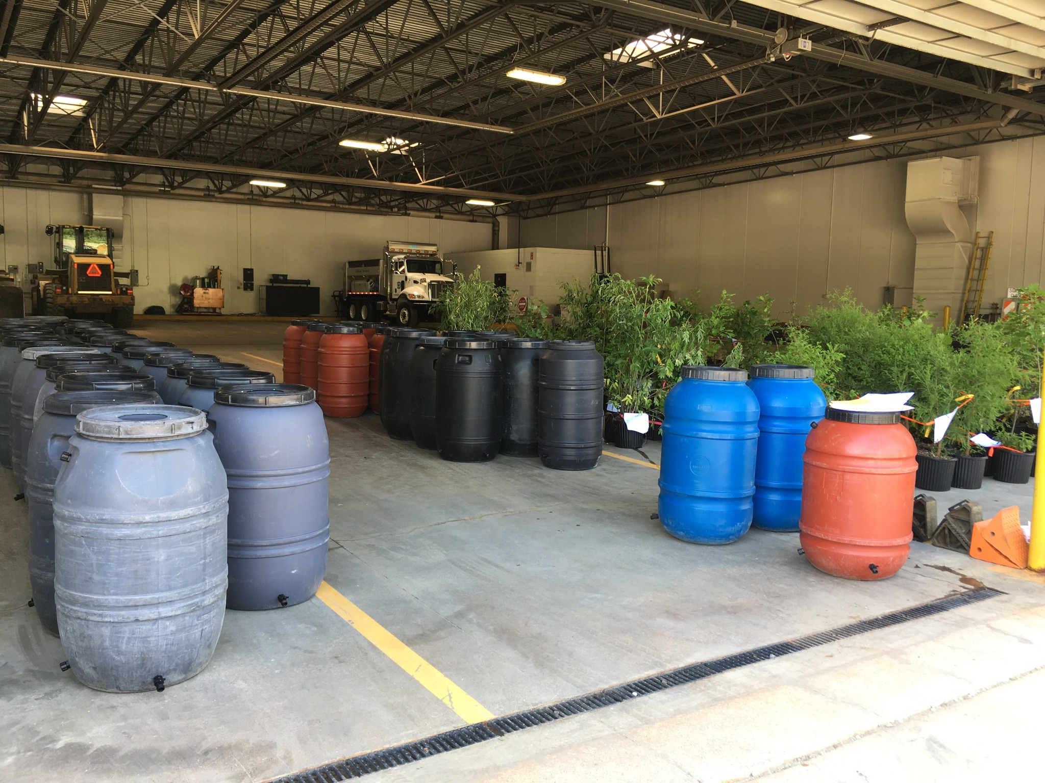
The Conservation Foundation sells rain barrels year-round through a partnership with Upcycle Products, Inc. The 55-gallon rain barrels are made of recycled food-grade plastic, come in a variety of colors and can be purchased online for $64.50 (plus tax) and picked up at The Conservation Foundation’s headquarters at McDonald Farm. Home delivery is also available. Barrels can also be purchased in-person at McDonald Farm or area events.

Buy a rain barrel online here.
Rain barrels are available for purchase and pick up every Thursday from 2 to 4p.m. April through September at:
The Conservation Foundation's McDonald Farm
10S404 Knoch Knolls Rd
Naperville, IL 60565

How Do I Install My New Rain Barrel?

View this guide or watch this video for easy installation tips.

